Daniel Schwartz  
Social Network Analysis 09-20-2022

Assignment 2

1. 1. Done
      1. The most popular child is C16, with 19 in-degrees.
      2. The In-Degree distribution looks relatively high at first and decreases, as the in degree gets higher. Although there are a number of semi popular kids getting 7 incoming edges.

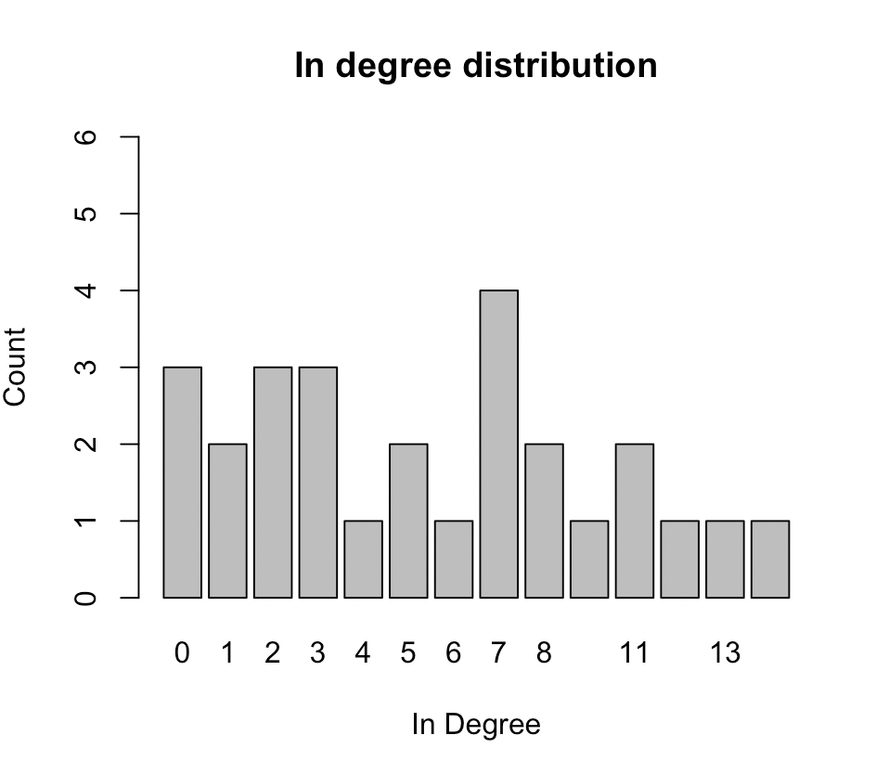

* + 1. The proportion of outgoing arcs being reciprocated is, or arc reciprocity, is 0.376, meaning only a third of all outgoing arcs are being reciprocated. Although, I have nothing to compare this to, I’d say the number falls fairly low compared to a very reciprocal group.
  1. 1. Attributes:

NodeName Gender

1 C1 1

2 C2 1

3 C3 1

4 C4 1

5 C5 1

6 C6 1

7 C7 1

8 C8 1

9 C9 1

10 C10 1

11 C11 1

12 C12 1

13 C13 2

14 C14 2

15 C15 2

16 C16 2

17 C17 2

18 C18 2

19 C19 2

20 C20 2

21 C21 2

22 C22 2

23 C23 2

24 C24 2

25 C25 2

26 C26 2

27 C27 2

* + 1. Density table:

1 2

1 0.295 0.161

2 0.106 0.333

* + 1. This density table shows that girls talk to girls more than boys talk to boys, but conversations between two of the same gender are more frequent than conversations between mixed genders. Boys initiate the conversation to girls slightly more than girls to boys.

1. 1. Hargens uses a nominalist conception of the boundaries of these networks because some papers are unable to be cited by others due to the visualization boundaries, but the visualization gives a general idea of frequently cited papers.
      1. The nodes of the network are papers, and the relations are citations between papers
      2. Reference networks are directed because one paper cites another paper
      3. Reference networks do include attributes. They are “possible references to recent papers”, “possible references to foundational papers”, and “possible references to the rest of the graph.
   2. The boundary Hargens uses is based on the recency of a paper. Foundational papers are located near the top, and recent papers are located on the diagonal boundary. Hargens obtained the data from literature reviews.